Use Case Document
V 1.0
CTMS Study Calendar Module
Robert H. Lurie Comprehensive Cancer Center of Northwestern University

DOCUMENT CHANGE HISTORY
Version Number | Date | Contributor | Description
V1.0 | 8/7/06 | Renee Webb | Use cases, release 1

Table of Content
1. Background/Summary 3
Document Overview 3
Related Documents 4
2. Actors and Authorization 5
Roles & Responsibilities: 5
Authorization Levels: 6
3. General Functions 7
Login on the module 7
Use Case Description: 7
Manage authentication and access data using User Provisioning Tool (UPT) 9
Use Case Description: 9
Logout of the module 10
Use Case Description: 10
4. Functional Use cases 11
Create new calendar 12
Use Case Description: 12
Create new period 13
Use Case Description: 13
Create new activity 14
Use Case Description: 14
View calendar template 15
Use Case Description: 15
View study list 16
Use Case Description: 16
5. Use Case Change Management and Traceability 18
6. Overall Requirements 20
Requirements Prioritization 20

Background/Summary
The business driver behind the caBIG CTMS Study Calendar Module is the creation of an open source, standards-compliant software application that can be used by organizations that manage patients on cancer clinical trials. The caBIG CTMS Study Calendar Module will support the application of a study template to study participants and enable the prospective forecasting of visit information and provide a framework for reviewing historical study calendar events. The caBIG CTMS Study Calendar will support studies that include therapeutic, observational, correlative, ancillary, and biobanking aspects. The standalone Study Calendar module will integrate with the components necessary to create study calendar templates (protocol authoring), be able to instantiate a template for study participant and represent study events for that participant. These study events will be uniquely identified at a study participant and event level, enabling the stable linking to external systems such as patient scheduling systems, laboratory interfaces, adverse event reporting modules, case report forms, and other event-based data that are specified by a study.
The study calendar will serve as an event-centric hub for linking these data, but the study calendar module itself will not model or extend into these domains.
Functionally, the Study Calendar will include features to support patient screening and registration, adaptable schedule definitions and security model implemented using the CSM that is suitable for multi-site protocols, alerts for upcoming events and missed events, ability to track and report on dates of anticipated versus actual events, and complete reporting of patient accrual, missed events, and schedule deviations. The Patient Study Calendar will support the accrual definitions necessary for CCSG reporting.

Document Overview
The Patient Study Calendar module will have three functional components that reflect the three aspects of the data model: a template view, a prospective view, and a retrospective view.
- The template view of the Patient Study Calendar module is an electronic representation of the eligibility/treatment/monitoring/follow-up lifecycle for a specific study, as typically listed in the study parameters table of the study protocol.
- The prospective view is the result of applying the template view to a specific participant with a start date. The prospective view is an instantiation of the template for a study participant and by combining the start date of that participant with the days specified in the template view, discrete dates for future events can be calculated.
- The third component to the Patient Study Calendar module is the retrospective view. Once the date of an event created by the prospective component has passed, details about that event must be entered to reconcile if it happened, when it happened, and provide a unique, stable identifier for these events that can be used by other modules and systems.
The Study Calendar Module is being developed with significant input from groups that have been identified as Primary Stakeholders in the project. These stakeholders are key contributors in defining system requirements and associated use cases. They include:
- A user group from the Robert H. Lurie Comprehensive Cancer Center of Northwestern University Clinical Research Office. This group meets as needed to provide information and feedback to the development team and is key in the development of use cases.
- A Requirements Group that includes representatives from several cancer center and development team members. This group holds weekly teleconferences and focuses on requirement specifications.
- The Study Calendar SIG, which has twice-monthly teleconferences. The focus of calls mirrors the activities underway in the development project, with the discussion of use cases and requirements as key agenda items.

Related Documents

Document Name | Version | Location
Study Calendar Module Vision and Scope Doc | V 1.03
Study Calendar Module Stakeholder Doc | V 1.0
Study Calendar Module System Requirements Specifications Doc | V 1.0

Actors and Authorization

Actors are defined by their assigned roles and responsibilities, resulting in varying levels of authorization and access to the module. The roles for the Study Calendar Module are listed below.

Roles & Responsibilities:

System Administrator | - Is a "super-user" who manages the application  - Approves and manages user registration process  - Grants users to a role within the application
Study Administrator | - Reviews completed Study Calendar templates to determine if they are complete and correct  - Determines which studies will be editable/viewable for each Clinical Research Coordinator and viewable for each Research Associate
Study Coordinator | - Creates new Study Calendars  - Views Calendars for which approval has been granted
Participant Coordinator | - Assigns Participants to Studies for which approval has been granted  - Generates Calendars for each Participant
Research Associate | - Views Calendars for which approval has been granted

Authorization Levels:

Authorization Level and Data type | Description
Class Level | This is a system wide level that is predefined by an administrator.
Object Level | This deals with an instance of an object within a class. This level deals with proprietary ownership of data.  An example of this would be: an individual who does not have ownership of a Protocol but has been given the authority to view de-identified data for the Protocol.
Attribute Level | This level deals with the individual details for an Object All individual data elements stored within the system must be secured in order to prevent access to unauthorized individuals. Due to the initiation of HIPAA it has become necessary to secure all Participant identifiers from non-authorized individuals.

Data Privilege- Defines the action that the actor may perform on the data
- Add: Submit new data into the system
- Edit: Update existing data
- Read: View only
- Disable: Record with associated data can no longer be viewed in the system.

Data Class Access | Description
Identified | A piece of data that directly or indirectly identifies the participant. This includes all HIPAA defined identifiers.
De-Identified Data | All HIPAA Identifiers have been stripped from the data displayed, with data still being linked back to patient information in the database.
Public | Data set that is Read only for all users

General Functions

Login on the module

Study Calendar Module
Actor
Entry
Module

Validation
Fails

Validation
Successful
Submit
System Displays role based user dashboard

Use Case Description: A user logs into the Study Calendar Module by supplying a username and password.

Use Case Name | Login on Module
Use Case ID | PSC_UC_001
Primary Actor | Registered User
Secondary Actor | None
Brief Description | In this use case a user logs into the system. Each individual user has a role and group and access permissions can be defined for the user.
Trigger | Navigate to the application using the appropriate URL.
Pre-conditions | The application is pre-loaded with the correct URL. The user authentication data is already present in the database.
Flow of Events | - The system presents a login screen that includes fields for username and password.  - The user provides his username, password and submits.  - The system successfully authenticates the user with the provided credentials using CSM  - A listing of studies is displayed to the user.
Post Conditions | None
Branch Point – <error handling> | Invalid Credentials (starts at Step 2 of the Flow of Events if the system indicates that the login or password provided is invalid):  3a.The system presents the login screen again and displays an error message that the login credentials were invalid.
Quality Use case | None
Related Use Cases | PSC_UC_002  PSC_UC_003
Business Rules | - Valid user name is alphanumeric 5-9 characters.  - Valid login requires user to be present in the study calendar database.

Manage authentication and access data using User Provisioning Tool (UPT)

Use Case Description: The System Administrator uses the UPT to manage user authentication and access to functionality and data within the Study Calendar Module by assigning users to roles.

Use Case Name | Authentication and Access Data
Use Case ID | PSC_UC_002
Primary Actor | System Administrator
Secondary Actor | None
Brief Description | The System Administrator uses the UPT to manage user authentication and access to data.
Trigger | None
Pre-conditions | - UPT application is already set up.  - The user authentication data is present in the database and he has access rights to the UPT.
Flow of Events | - The UPT application login page is displayed.  - The system administrator provides username, password and the application (context) name for login.  - The system successfully redirects the user to the UPT tool.  - The user uses the UPT tool to create and manage user access rights and assign users to roles.
Post Conditions | None
Branch Point – <error handling> | None
Quality Use case | None
Related Use Cases | PSC_UC_001  PSC_UC_003
Business Rules | None

Logout of the module

Use Case Description: The user has finished using the Study Calendar Module and logs out of the system.

Use Case Name | Logout of Module
Use Case ID | PSC_UC_003
Primary Actor | Registered User
Secondary Actor | None
Brief Description | In this use case a user logs out of the system.
Trigger | None
Pre-conditions | The user is logged in.
Flow of Events | - The user clicks on the Logout link or button.  - The system successfully logs out the user.  - The system redirects the user to the login page.
Post Conditions | None
Branch Point – <error handling> | None
Quality Use case | None
Related Use Cases | PSC_UC_001  PSC_UC_002
Business Rules | None

Functional Use cases

The diagram below represents the flow of events that relate to the study calendar module and is instrumental in the creation of the individual functional use cases. It describes the inter-relationships of actors at the research site and their interaction with the study calendar or movement of a subject on trial.

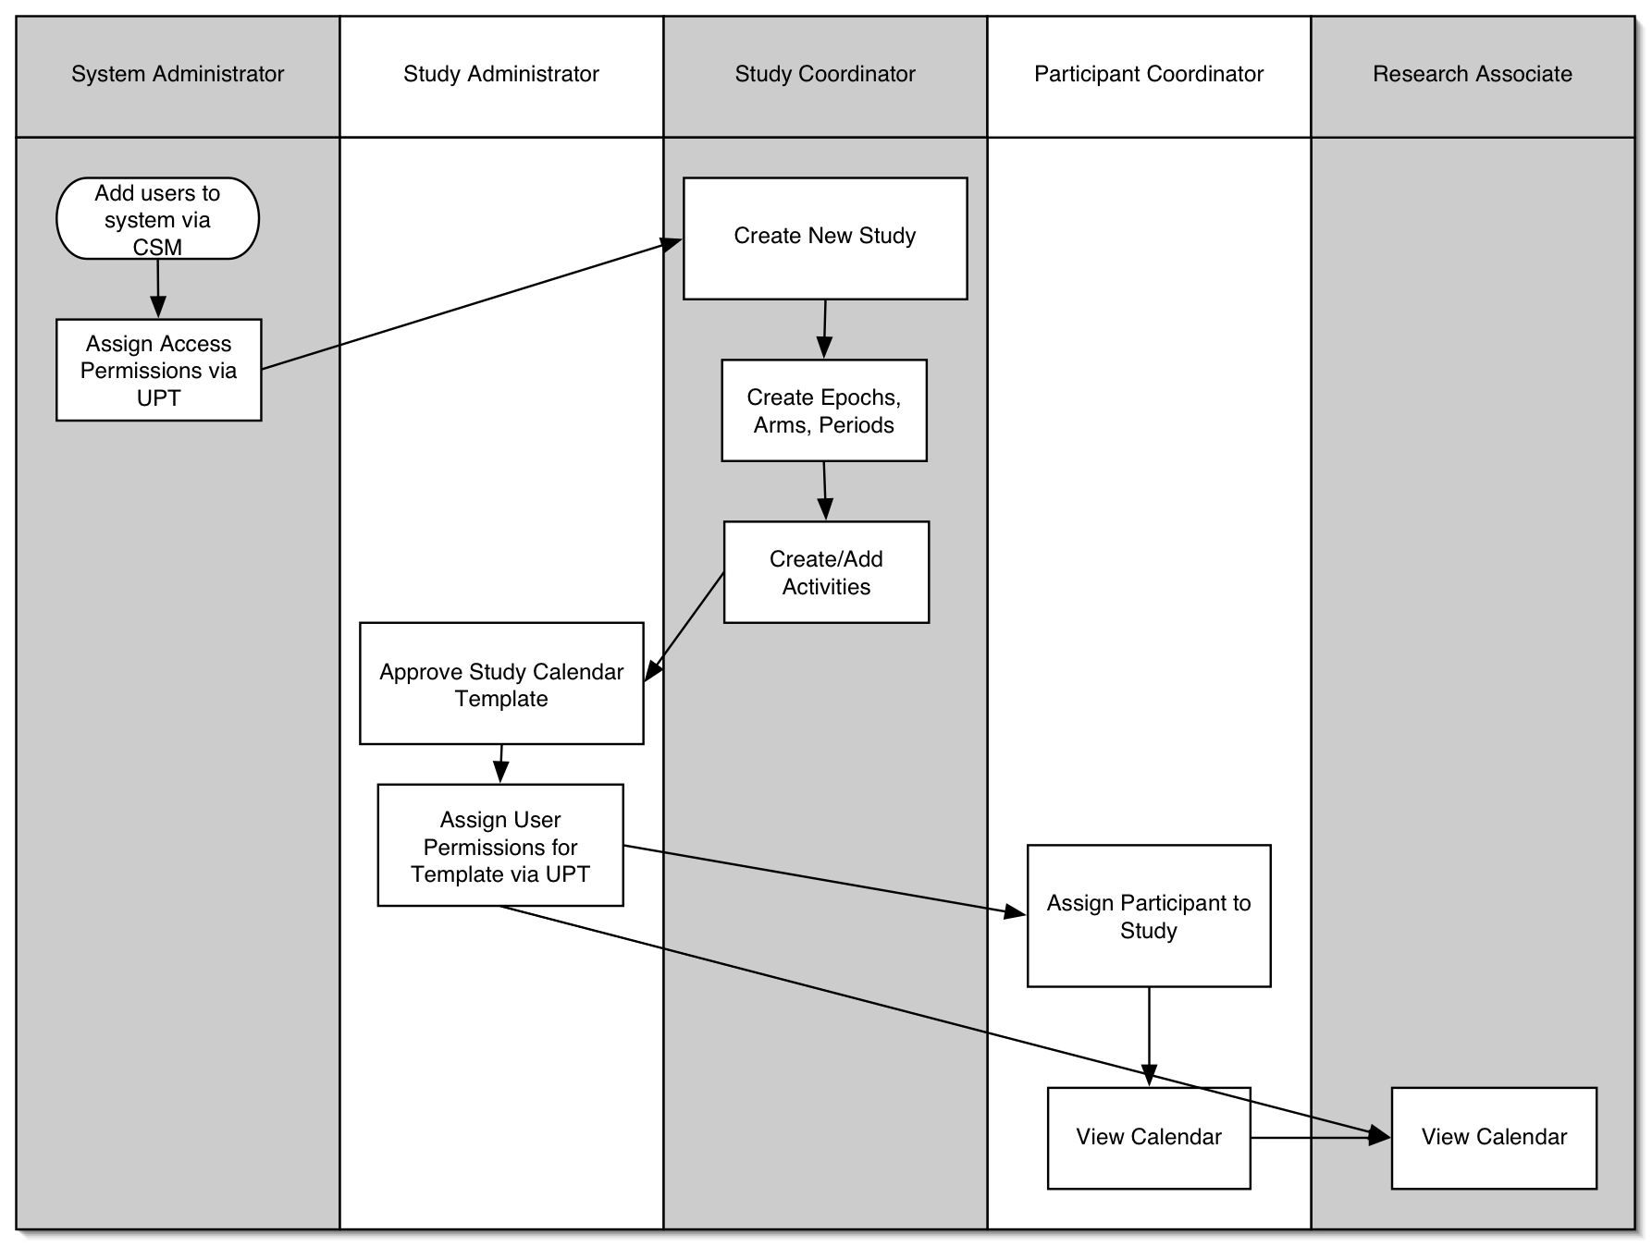

Release 1 functional use cases relate to the creation of a study template and are provided below.

Create new calendar

Use Case Description: A Study Coordinator clicks a link to create a new study. This begins the process of adding a new study to the Study Calendar Module.

Use Case Name | Create New Calendar
Use Case ID | PSC_UC_004
Primary Actor | Study Coordinator (SC)
Secondary Actor | None
Brief Description | Register a protocol for use with the study calendar.
Trigger | New protocol received.
Pre-conditions | This requires knowledge of the protocol’s short title, the names of its epochs, and the names of their arms (if any).
Flow of Events | - The SC accesses the application.  - The SC enters the protocol’s short title.  - The SC enters the name for the first epoch.  - The SC enters the arms for this epoch if there are any.  - The SC repeats steps 3 and 4 for additional epochs, if any.  - The SC submits the entries.  - The application indicates that the study was successfully created and displays a menu of options for filling in details of the protocol.
Post Conditions | A new study is available in the system.
Branch Point – <error handling> | None
Quality Use case | None
Related Use Cases | PSC_UC_001
Business Rules | None

Create new period

Use Case Description: During the creation of a study, the Study Coordinator will be able to add periods to the arms of a study.

Use Case Name | Create New Period
Use Case ID | PSC_UC_005
Primary Actor | Study Coordinator (SC)
Secondary Actor | None
Brief Description | Create a new period for a study.
Trigger | None
Pre-conditions | The SC has selected a study from a list of open templates.
Flow of Events | - The SC selects the arm of the study the period should be added to.  - The SC enters a name for the period.  - The SC enters the start day for the period.  - The SC enters the duration of the period in days or weeks.  - The SC enters the number of times the period repeats.  - The SC creates the period.  - Application saves the period.  - Application indicates the period has been successfully created.
Post Conditions | A new period is associated with the selected arm of the selected study.
Branch Point – <error handling> | The study is a single-arm study:  1a. The SC adds a period to the study without selecting an arm.  A period with the same name exists for that arm:  7a. The SC provides a new name.
Quality Use case | None
Related Use Cases | PSC_UC_004
Business Rules | None

Create new activity

Use Case Description: The Study Coordinator will be able to create new activities within the system if the required activity does not already exist.

Use Case Name | Create New Activity
Use Case ID | PSC_UC_006
Primary Actor | Study Coordinator (SC)
Secondary Actor | None
Brief Description | Create a new activity in the system.
Trigger | None
Pre-conditions | New calendar has been created.
Flow of Events | - The SC provides a short name for the activity.  - The SC types in a short description of the activity.  - The SC selects the activity type from a list. (Refer to Business Rules)  - Application saves the activity.  - Application indicates the activity was created successfully created.
Post Conditions | An activity is available in the system.
Branch Point – <error handling> | There is already an activity with the same short name:  - Application indicates that an activity with that name already exists.  - SC provides a new short name.
Quality Use case | None
Related Use Cases | PSC_UC_004  PSC_UC_005
Business Rules | Activity types include:  - To be determined by the SIG

View calendar template

Use Case Description: A Study Administrator or Study Coordinator will be able to view the calendar template, which will display the arms and periods of a study.

Use Case Name | View Calendar Template
Use Case ID | PSC_UC_007
Primary Actor | Study Administrator (SA) or Study Coordinator (SC)
Secondary Actor | None
Brief Description | View a schematic of the current sate of the calendar template, week-by-week with all arms and defined periods.
Trigger | None
Pre-conditions | A study has been created and one or more periods have been defined for it (or its arms if multi-armed).
Flow of Events | - The SA or SC accesses the application.  - The SA or SC selects the study in the study list.  - An ascending list of days on the template will be displayed by default. Optionally, the user can select a wall-calendar-like 7-column grid to be displayed. Each “day” shows which periods of which arms span that day.
Post Conditions | None.
Branch Point – <error handling> | None
Quality Use case | None
Related Use Cases | PSC_UC_001  PSC_UC_008
Business Rules | None

View study list

Use Case Description: After logging on to the Study Calendar Module, the user is presented with a list of available studies that have been created or are in the process of being created and are appropriate for that user to view.

Use Case Name | View Study List
Use Case ID | PSC_UC_008
Primary Actor | Study Administrator, Study Coordinator, Participant Coordinator, or Research Associate.
Secondary Actor | None
Brief Description | Shows all protocols with calendars.
Trigger | None
Pre-conditions | At least one study has been created.
Flow of Events | - The user logs on to the application.  - The application determines which studies are appropriate for that user to view and/or modify.  - The application displays a list of the appropriate studies.
Post Conditions | None
Branch Point – <error handling> | None
Quality Use case | None
Related Use Cases | PSC_UC_001  PSC_UC_004
Business Rules | None

Assign activities to periods

Use Case Description: The last step in setting up a calendar template is to select the activities that will take place in each period.

Use Case Name | Assign activities to periods
Use Case ID | PSC_UC_009
Primary Actor | Study Coordinator (SC)
Secondary Actor | None
Brief Description | Select the activites for a period of an arm (or a no-arm epoch)
Trigger | Calendar template being built
Pre-conditions | Calendar must have at least one period
Flow of Events | - The SC accesses the application  - The SC selects a study  - The SC selects a period within that study  - The application displays all the activities in the system, the number of days in the period, and a list of activities that have already been assigned to the period  - The SC selects a new activity and adds it to the period  - The SC indicates on which days of the period the activity will be performed (possibly more than once per day)  - The SC repeats 5 and 6 until satisfied  - The SC submits the assignments  - The system stores the assignments and redisplays the complete template with them in place
Post Conditions | The template has one or more activities assigned to one of its periods.
Branch Point – <error handling> | None
Quality Use case | None
Related Use Cases
Business Rules | None

Assign Participant to Study

Use Case Description: A Participant Coordinator assigns a participant to a study.

Use Case Name | Assign Participant to Study
Use Case ID | PSC_US_010
Primary Actor | Participant Coordinator (PC)
Secondary Actor | None
Brief Description | PC assigns a participant to a study.
Trigger | PC follows link from template view of a study.
Pre-conditions | Must know to which study the participant should be assigned.
Flow of Events | - The PC accesses the application  - The PC selects a study  - The PC follows link to add a participant to the study.  - The PC selects the participant from a list of available participants.
Post Conditions | The participant is now associated with the study and will appear in a list of all participants assigned to that study.
Branch Point – <error handling> | None
Quality Use case | None
Related Use Cases | PSC_UC_011, PSC_UC_012
Business Rules | None

Create new Participant

Use Case Description: A Participant Coordinator creates a new Participant in the system if the Participant does not already appear there.

Use Case Name | Create New Participant
Use Case ID | PSC_US_011
Primary Actor | Participant Coordinator (PC)
Secondary Actor | None
Brief Description | PC assigns a participant to a study.
Trigger | PC follows link from Assign Participant page.
Pre-conditions | Must know details about Participant to be added.
Flow of Events | - PC follows link to Assign Participants from Study Template View.  - If Participant is not in available list, PC follows link to create a new Participant.  - PC submits name, DOB, gender, and some sort of ID for to create the Participant.
Post Conditions | The participant is now available in the database to be added to a study.
Branch Point – <error handling> | None
Quality Use case | None
Related Use Cases | PSC_UC_010, PSC_UC_012
Business Rules | None

Mark Template as Complete

Use Case Description: A Study Administrator selects a Study Template, reviews it, and marks the template as complete. A completed template may then have participants assigned to it by a Participant Coordinator.

Use Case Name | Mark Template as Complete
Use Case ID | PSC_US_013
Primary Actor | Study Administrator (SA)
Secondary Actor | None
Brief Description | SA assigns a participant to a study.
Trigger | SA logs on to the application and follows a link to view the template for a study.
Pre-conditions | Study Coordinator creates study template.
Flow of Events | - SA follows link to view template for a Study.  - SA reviews the template for accuracy and completeness.  - If approved, the SA marks the template as being complete
Post Conditions | The participant is now available in the database to be added to a study.
Branch Point – <error handling> | None
Quality Use case | None
Related Use Cases | PSC_UC_010, PSC_UC_012
Business Rules | None

Generate calendar for participant

Use Case Description: After a Participant Coordinator assigns a participant to a study, the participant gets his or her own custom copy of the calendar.

Use Case Name | Generate calendar for participant
Use Case ID | PSC_US_012
Primary Actor | Participant Coordinator (PC)
Secondary Actor | None
Brief Description | Schedule a participant’s activities on a protocol
Trigger | Participant added to a study.
Pre-conditions | Must know when the participant will begin in the study and which arm he or she will be on in the first epoch (if applicable)
Flow of Events | - The PC accesses the application.  - The PC selects a study.  - The PC selects a participant in that study.  - The PC enters the date for “day 1” for that participant in that study’s first epoch.  - The PC selects the arm for the patient in the first epoch (if required).  - The PC submits the information.  - The application indicates that the participant schedule was created.
Post Conditions | The participant has personalized schedule for his or her involvement in the study
Branch Point – <error handling> | None
Quality Use case | None
Related Use Cases
Business Rules | None

Use Case Change Management and Traceability
All changes in requirements are managed and recorded in our ticket tracking system, https://trac.bioinformatics.northwestern.edu/studycalendar . This ticket system allows us to link tickets to our wiki and version control system. All developers, testers, and QA personnel have the ability to create and edit tickets, others are granted this right by request.
In addition to the required fields of Date, Submitted By, Change Type, Change ID, Change Details, and Status, our change management system also allows us to track Priority, Completion Time Estimate, Assigned To, Associated Component, Associated Release, and Change History. Project managers receive an automated notification anytime a ticket is added or modified.

Sample Ticket:
Field | Sample Data
Date | 6/26/06
Submitted By | Mmhohman
Change type | Enhancement
Change ID | Ticket #19
Change Details | Create an activity, providing a name, activity type and test description, shares across all studies
Status | Closed
Priority | Major
Completion Time Estimate | 20 hours
Assigned To | Jaron
Associated Component | Software
Associate Release | Release 1
Change History | Chronographic list of changes to ticket

Change Workflow:
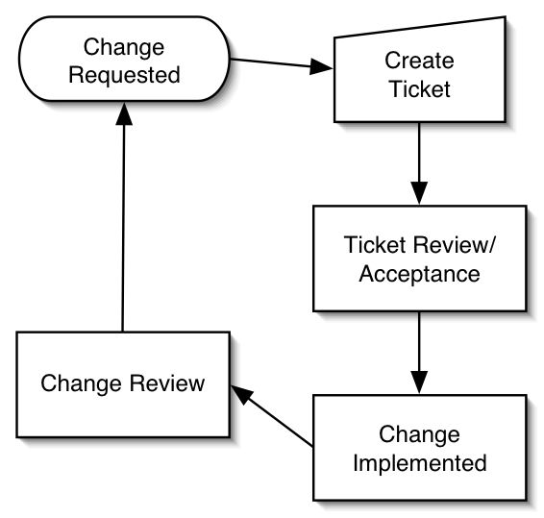

Overall Requirements

Requirements Prioritization

Priority | Use Case Name | Supp Requirement Ref #
1 | Login – PSC_UC_001 – PSC_UC_003
1 | Create template –  PSC_UC_004 - PSC_UC_008

